Permess bv Enterseweg 7

7471 SB Goor, NETHERLANDS

**OEKO TEX®**

ertificate

CENTEXBEL TECHNOLOGIEPARK 70

9052 ZWIJNAARDE, BELGIUM

**OEKO-TEX®STANDARD 100**

**Permess bv**

is granted the OEKO-TEX®STANDARD 100 certification and the right to use the trademark.

# SCOPE

Fusible interlinings, based on knitted fabrics, woven fabrics or thermo-bonded non-woven - in polyamide, polyester, cotton and/or viscose with polyamide, polyester, HDPE or EVA coating in all colours - based on materials pre-certified according to OEKO-TEX® STANDARD 100

**OEKO**

**TEX®**

**STANDARD**

**100**

70319623

Centexbel

# PRODUCT CLASS

I (baby articles) - Annex 6

# This certificate 70319623 is valid until 31.03.2025.

**SUPPORTING DOCUMENTS**

Test report : 1452

Declaration of conformity in accordance with EN ISO 17050-1 as required by OEKO-TEX"

*v* OEKO-TEX" Terms of Use (ToU)

Certification Officer

Further compliance information (REACH, SVHC, POP, GB18401 etc.) can be found on oeko-tex.com/en/faq.

The certificate is based on the test methods and requirements of the OEKO-TEX' STANDARD 100 that were in force at the time of evaluation.

Zwijnaarde, 2024-04-18

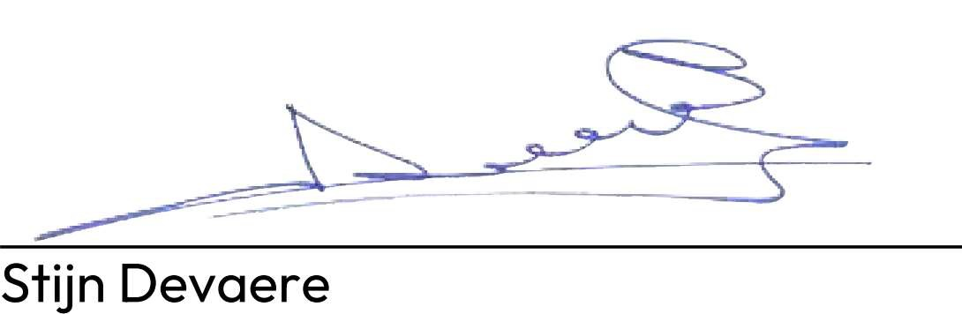

**OEKO-TEX Service GmbH** Genferstrasse 23, CH-8002 Zurich